**Laporan Implementasi Database**

**Aplikasi Penjualan Keripik**

Tabel Awal



Tabel 1NF

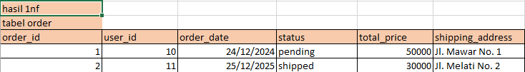

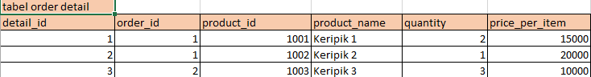

Tabel 2nF

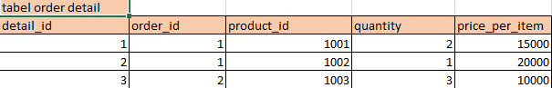

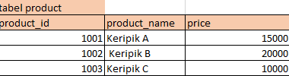

Tabel 3nF

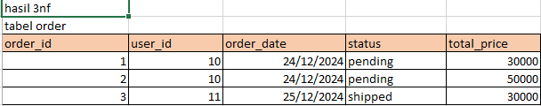

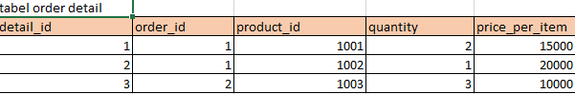

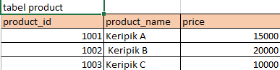

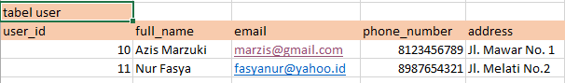

**Struktur Tabel**

1. Users: Menyimpan data pelanggan
2. Products: Menyimpan data produk
3. Orders: Menyimpan data transaksi utama
4. Order_Details: Menyimpan detail produk dalam setiap transaksi

**Skema Tabel**

Tabel user

CREATE TABLE users (

user_id INT AUTO_INCREMENT PRIMARY KEY,

full_name VARCHAR(100) NOT NULL,

email VARCHAR(100) NOT NULL,

phone_number VARCHAR(20),

address TEXT

);

Tabel products

CREATE TABLE products (

product_id INT AUTO_INCREMENT PRIMARY KEY,

product_name VARCHAR(100) NOT NULL,

price DECIMAL(10, 2) NOT NULL

);

**Tabel orders**

CREATE TABLE orders (

order_id INT AUTO_INCREMENT PRIMARY KEY,

user_id INT NOT NULL,

order_date DATETIME NOT NULL,

status ENUM('pending', 'paid', 'shipped', 'completed', 'canceled') NOT NULL,

total_price DECIMAL(10, 2) NOT NULL,

FOREIGN KEY (user_id) REFERENCES users(user_id)

);

Tabel order details

CREATE TABLE order_details (

detail_id INT AUTO_INCREMENT PRIMARY KEY,

order_id INT NOT NULL,

product_id INT NOT NULL,

quantity INT NOT NULL,

price_per_item DECIMAL(10, 2) NOT NULL,

FOREIGN KEY (order_id) REFERENCES orders(order_id),

FOREIGN KEY (product_id) REFERENCES products(product_id)

);

Menampilkan Detail Pesanan dengan Informasi Pelanggan

SELECT

orders.order_id,

orders.order_date,

users.full_name AS customer_name,

users.email AS customer_email,

users.address AS shipping_address,

orders.status,

orders.total_price

FROM orders

JOIN users ON orders.user_id = users.user_id;

Menampilkan Detail Produk dalam Pesanan

SELECT

orders.order_id,

products.product_name,

order_details.quantity,

order_details.price_per_item,

(order_details.quantity * order_details.price_per_item) AS total_price_per_product

FROM order_details

JOIN products ON order_details.product_id = products.product_id

JOIN orders ON order_details.order_id = orders.order_id;

Pelanggan dengan Total Pembelian Tertinggi

SELECT

users.user_id,

users.full_name,

users.email,

total_spent.total_price AS total_spent

FROM users

JOIN (

SELECT

user_id,

SUM(total_price) AS total_price

FROM orders

GROUP BY user_id

) AS total_spent ON users.user_id = total_spent.user_id

ORDER BY total_spent.total_price DESC

LIMIT 1;

Produk yang Belum Pernah Dibeli

SELECT

products.product_id,

products.product_name,

products.price

FROM products

WHERE product_id NOT IN (

SELECT DISTINCT product_id

FROM order_details

);

Menghitung Total Harga Pesanan

DELIMITER $$

CREATE FUNCTION calculate_order_total(orderID INT)

RETURNS DECIMAL(10, 2)

DETERMINISTIC

BEGIN

DECLARE total DECIMAL(10, 2);

SELECT SUM(quantity * price_per_item) INTO total

FROM order_details

WHERE order_id = orderID;

RETURN total;

END $$

DELIMITER ;

Mengupdate Total Harga Pesanan

DELIMITER $$

CREATE TRIGGER update_order_total

AFTER INSERT ON order_details

FOR EACH ROW

BEGIN

UPDATE orders

SET total_price = (SELECT calculate_order_total(NEW.order_id))

WHERE order_id = NEW.order_id;

END $$

DELIMITER ;

Menghapus Pesanan yang Tidak Dibayar dalam 7 Hari

DELIMITER $$

CREATE EVENT delete_old_pending_orders

ON SCHEDULE EVERY 1 DAY

DO

BEGIN

DELETE FROM orders

WHERE status = 'pending' AND order_date < NOW() - INTERVAL 7 DAY;

END $$

DELIMITER ;

Kesimpulan

Desain database ini mencakup kebutuhan untuk mendukung aplikasi penjualan online, mulai dari pengelolaan data pelanggan, produk, pesanan, hingga detail transaksi. Fungsi, trigger, dan event yang disediakan membantu dalam otomasi perhitungan dan pemeliharaan data, sehingga meningkatkan efisiensi dan konsistensi sistem..